<https://www.uml-diagrams.org/activity-diagrams-examples.html>

MODULE 1 – Tutorial Questions

**Question: Q1** A soft drink vending machine accepts coins for a variety of products. When the amount of money deposited into the machine is equal to or greater than the price of any of its available products, the respective product selection buttons will be enabled for the user to make the selection. After the user has made a valid selection, the machine will dispense the soft drink, together with the change (if applicable).

Draw the Use case diagram , Class Diagram, Sequence diagram, collaboration diagram,Activity Diagram, state chart diagram for this vending machine.

**Ans.a.**Use case Diagram

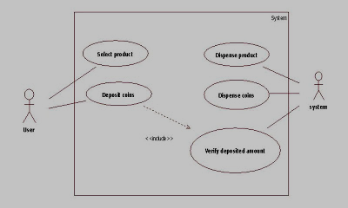

b.Class Diagram

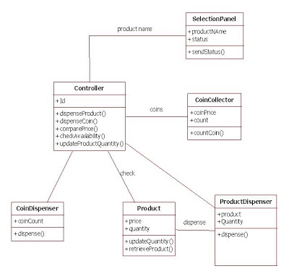

c.Sequence Diagram

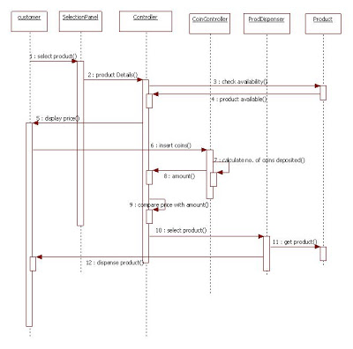

d Collaboration Diagram

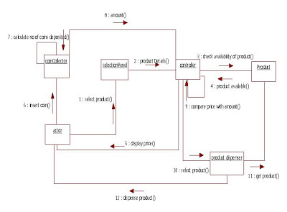

e.Activity Diagram

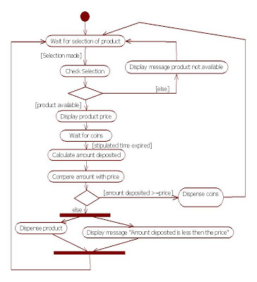

f. State chart diagram

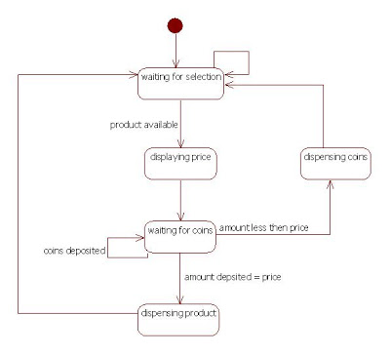

**Question: Q2** Consider the following system for Online Theatre Booking (for multiplex). Following are the minimum requirement of the system from the perspective of a user who is going to use this online system. User should be a registered member. User can book any number of tickets on availability. User should be able to search for the availability of tickets on selecting a particular movie. Once user books the ticket a token number will be generated so that on providing this token he will be able to collect tickets before show from theatre premises. User can cancel all or some seats of the ticket by providing token number before 1 Hr of scheduled time for that movie. Identify the actors for the application and draw the use case diagram.

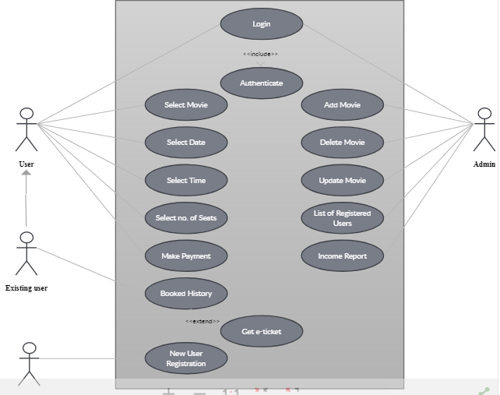

**Question: Q3** A simple digital watch has a display and two buttons to set it, the A button and B button. The watch has two modes of operation, display time and set time. In the display time mode, the watch displays hours and minutes, separated by a flashing colon. The set time mode has two sub modes, set hours and set minutes. The A button selects modes. Each time it is pressed the mode advances in the sequence: display, set hours, set minutes, display, etc. Within the sub modes, the capital B button advances the hours or minutes once each time it is pressed. Buttons must be released before they can generate another event. Prepare a state diagram of the watch. Also show the activity effects and do activities in the state diagram.

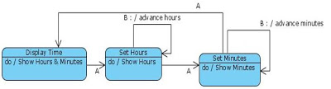

**Question: Q4** Draw the state diagram for a telephone line. At the start of a call, the telephone line is idle. When the phone is removed from the hook, it emits a dial tone and can accept the dialing of digits. Upon entry of a valid number, the phone system tries to connect the call and route it to the proper destination. The connection can fail if the number or trunk are busy. If the connection is successful the called phone begins ringing. If the called party answers the phone, a conversation can occur. When the called party hangs up the phone disconnects and rewards to idle when put on hook again.

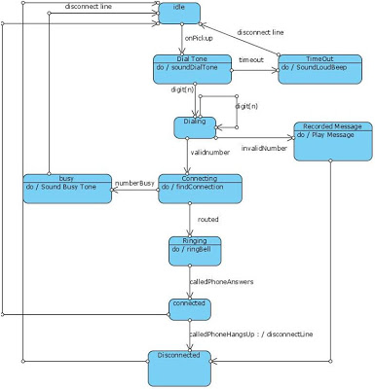

**Question: Q5** Prepare an activity diagram for computing a restaurant bill. There should be a charge for each delivered item. The total amount should be subject to tax. There is a service charge of 18% for groups of six or more and 10% for smaller groups. Any coupons and gift certificates submitted by the customer should be subtracted.

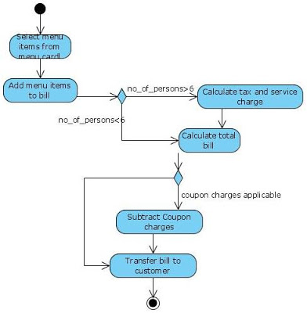

**Question: Q6** Draw the interaction diagram for the following scenario of adding a new book to a catalogue in which book seller may use to add new book titles to an internet book store website. The main flow of events is given below. The System displays, add new book The seller types in the book details (Title, ISBN, Price ..etc) and Clicks add book button The system checks whether each field has a value has a value, and whether the price is numeric (>0) The system also checks whether there is a matching ISBN in the book store Once all the conditions satisfied the system will create and add new book in the database